<https://github.com/johnopsahl/IfThenPaint_Image2Gcode>

First create a file called data beside the python codes, then create a txt called image_properties.txt, then script run sequence:

**add_image_properties.py**

**size_image.py**

**quantisize_image.py**

after given how many colors we want, we get output in file data (it will extract each color into a image):

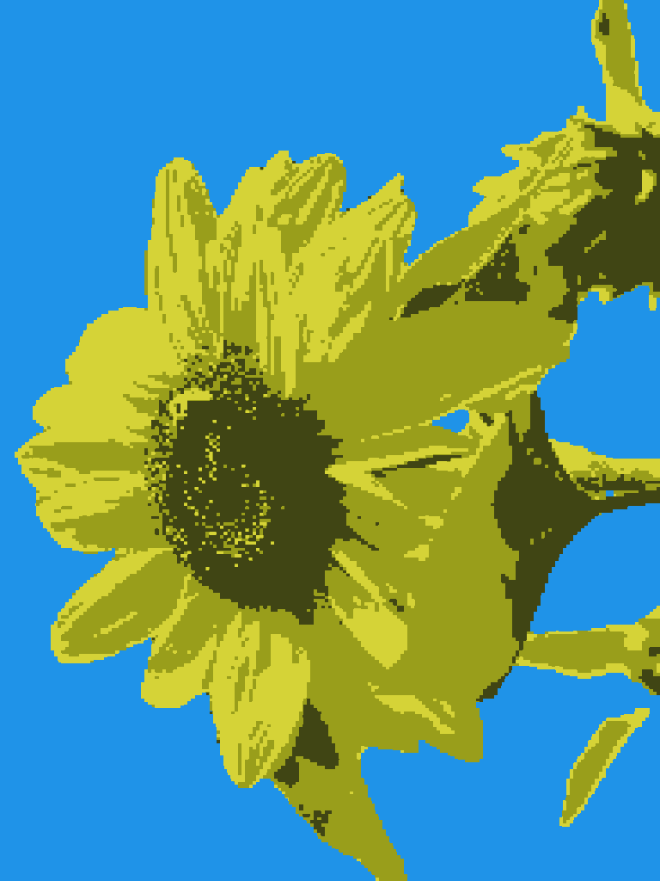

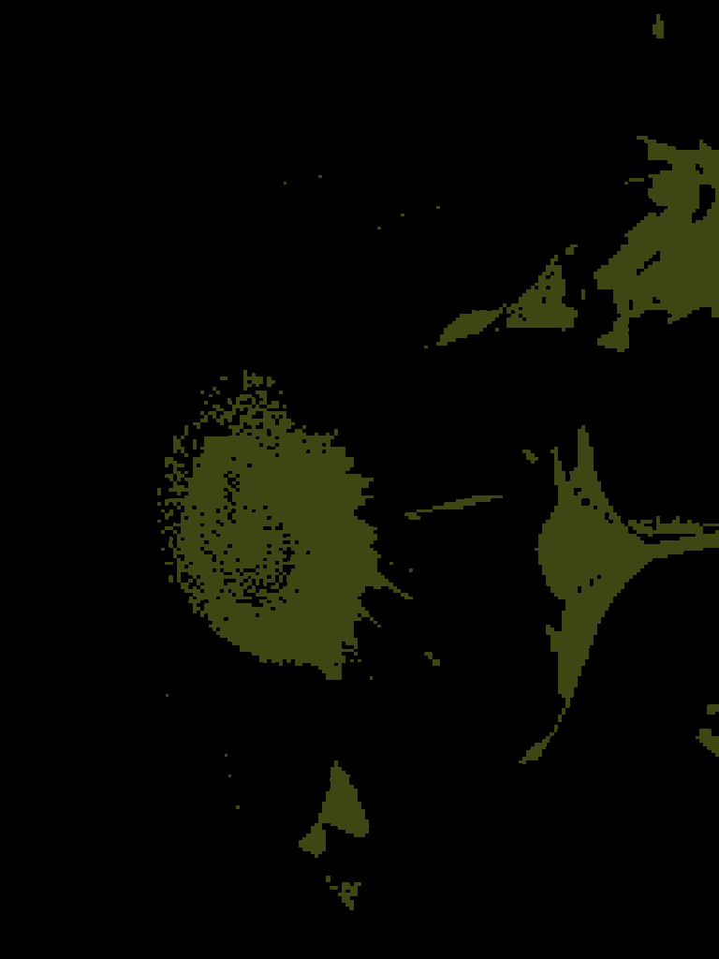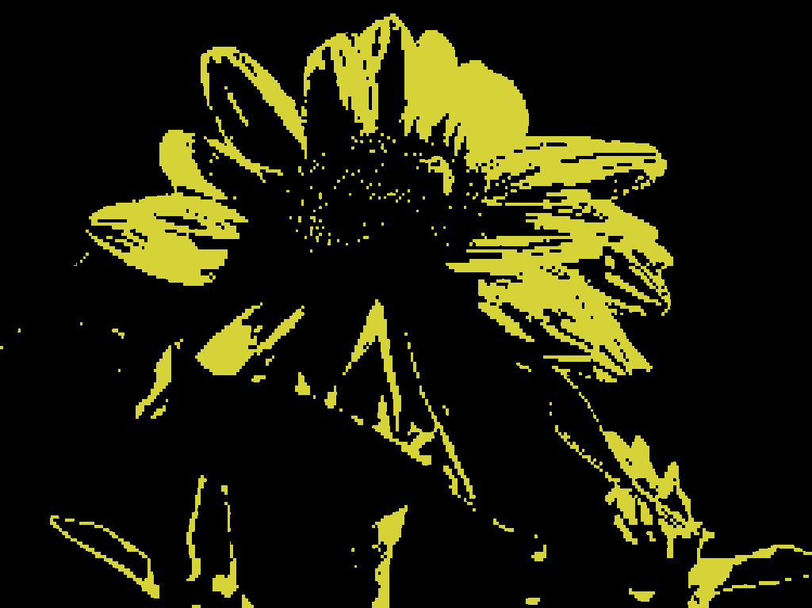

Then open **DrawEdge20.m**

Uncomment line 51 which is %I = imread(uigetfile);

Comment line 58 which is I = imread('color_center_3.png');

Then we can change some parameter

Then we execute and select the file



then we open **Untitled23.m**

and it will draw:

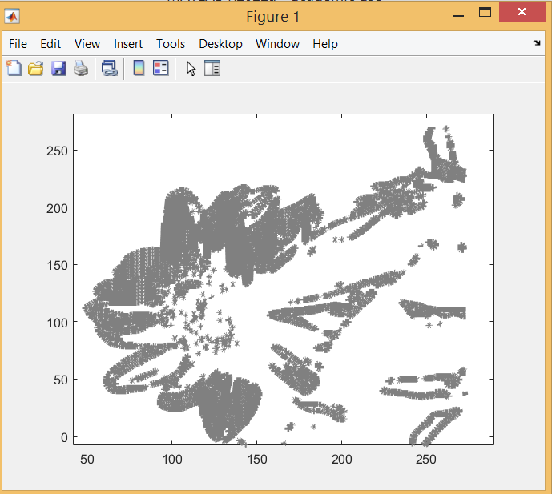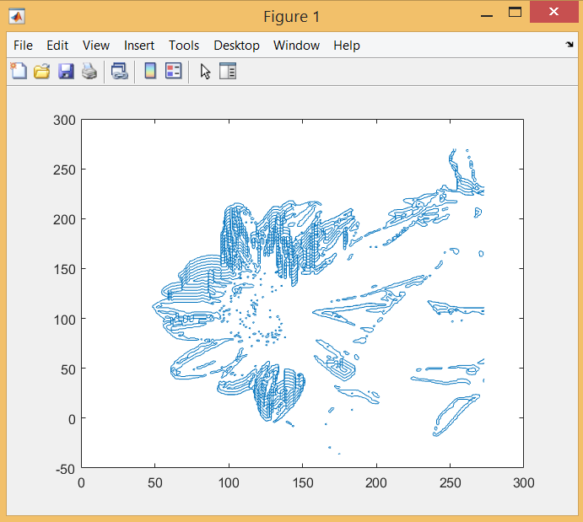

Other ideas:

image to gcode online (only black will be drawn) <https://www.thuijzer.nl/image2gcode/>

Images to G-Code <https://www.scan2cad.com/blog/cnc/convert-jpg-to-g-code/>

Generate G code from Image using Inkscape and Python <https://blnlabs.com/generate-g-code-from-image-using-inkscape-and-python/>

G code viewer <https://ncviewer.com/>